Assessment of Hydrogen Production Potential from Wind power in Vietnam

ABSTRACT: Hydrogen production technology from wind energy is one of the feasible methods to shift dependence on fossil fuels to clean energy in the near future. In Vietnam, the Government is also developing policies and regulations to promote hydrogen industry development. However, the efficiency of hydrogen production from areas with different potential for wind power exploitation in Vietnam has not yet been researched to provide a sufficient basis for investors to develop projects. In this paper, the hydrogen production potential from wind power systems is analyzed based on the wind energy potential in each region in Vietnam with the support of SAM software and hydrogen production formulas. Phu Yen province (South Central region) and Dak Lak province (Central Highlands region) with the highest wind energy potential have the largest hydrogen production of 45,286.1 kg/year and 42,675.4 kg/year, respectively. Wind power will help reduce large amounts of CO₂ emissions into the environment by replacing grid electricity that uses fossil fuels in the electrolysis process. The amount of CO₂ emission reduction is determined by corresponding to the amount of wind power produced for the hydrogen generation process. Phu Yen province has the highest CO₂ emission reduction of 1,792,968 kg/year while Ho Chi Minh city has the lowest value of 859,233 kg/year. The study results can be referenced by managers, consultants, and investors to support the development of green hydrogen sector in Vietnam.
KEYWORDS: hydrogen energy, wind power, electricity, CO₂ emission reduction.

NOMENCLATURE AND ABBREVIATION
AC - Alternating current
DC - Direct current
$E_{out}$ - Annual electrical energy output (kWh)
E_{con} - Amount the energy consumption in the electrolyzer (kWh)
EFgrid - tCO₂ emission coefficient of Vietnam's power grid (tCO₂/MWh)
eff_{con} - Performance of rectifier efficiency (%)
𝐹_{𝑎𝑑𝑗,𝑗} - Hourly adjustment factor due to various losses (h)
H - Amount of hydrogen produced (Nm³)
𝐿 - Loss correction factor due to the wake losses (%)
𝑁 - Number of turbines in the wind farm (unit)
𝑃_{𝑤𝑓,𝑗 -} Electrical output of wind farm in hour 𝑗 (kWh/h)
𝑃_{𝑗,𝑛} - Electrical output of turbine 𝑛 in hour 𝑗 (kWh/h)
R_{tCO2e} - Average annual CO₂ emission reduction (ton)
SAM - System Advisor Model

1. INTRODUCTION
Currently, hydrogen plays an extremely important role in socio-economic and environmental development. Hydrogen can be used to produce clean energy, helping to reduce dependence on traditional energy sources (Kalppana Chelvam, 2024).
Green hydrogen (Qusay Hassan, 2024) produced from renewable electricity systems has great potential to shift dependence on fossil fuels to clean energy in the near future. Currently, hydrogen production from renewable power sources in general and wind power in particular has been receiving research attention from laboratories around the world. Flavia Franco (Flavia Franco, 2020) conducted a study on a model of a hydrogen production plant from wind and solar power sources in Portugal with the help of Energy Plan software. The researcher (Li Z, Hou S, Cao X, et al, 2021) proposed a mathematical model and control system design for hydrogen production in a wind power system and gas turbines using MATLAB software. Ashish Sedai (Ashish Sedai et al, 2023) evaluated the possibility of producing hydrogen from wind energy in the US. G. AlZohbi (G. AlZohbi et al, 2023) studied the potential of using excess wind energy to produce hydrogen in four sites located in Saudi Arabia. Xue Q (Xue Q et al, 2021) analyzed the investment efficiency of hydrogen production from wind power through electrolysis and contributed to China's carbon emission reduction goal. Javaid, A (Javaid, A et al, 2022) built a machine learning method to predict hydrogen production based on wind energy in suburban environments. Xiong Wu (Xiong Wu et al, 2020) proposed a cooperative method between hydrogen fuel stations and wind turbines to optimize hydrogen production and storage efficiency. Opakhai (Opakhai et al, 2024) analyzed the difficulty of green hydrogen energy development in Kazakhstan. Besides, a new hydrogen production roadmap by 2040 in Kazakhstan was proposed. Mostafa Rezaei (Mostafa Rezaei et al, 2018) investigated the economic and social aspects of using wind power systems in 3 typical cities in Iran to produce hydrogen. In this study, five sets with different rated capacities (from 5 kW to 100 kW) were evaluated in 3 cities. 60 kW wind turbine was the most suitable type with the least payback period to produce hydrogen in 3 cities. The research of Yi Zheng (Yi Zheng et al, 2023) evaluated the economic performance of off-grid wind hydrogen systems across 112 sites in seven countries by using detailed electrolysis models. Hydrogen production systems from 4.2 MW wind turbine in China and Denmark are the best cost-competitive due to abundant resources and lower investment costs.
In Vietnam, the Government (Prime Minister, 2023; Prime Minister, 2024) is also developing policies and regulations to promote hydrogen industry development. These policies and strategies have created the legal basis and direction for hydrogen development in Vietnam. However, there are still many challenges that need to be resolved such as the cost of hydrogen production is still high, the infrastructure for producing and using hydrogen is lacking and the competitiveness of hydrogen compared to other fossil fuels is still limited. Now, green hydrogen (Anh Tuan Hoang, 2023) is a powerful solution in the global pursuit of a green future. Vietnam boosts green hydrogen production by expanding renewable energy capacity and reducing solar and wind production costs, offering great prospects (Nguyen, H. L, 2021) with high renewable energy potential and a fast growth rate in renewable energy, especially wind power. The applications of green hydrogen in Vietnam are vast (Nguyen Huu Luong, 2021) such as being used in industries of steel and chemicals. Vietnam has had some studies on hydrogen production from renewable energy sources (Vu et al, 2022; Thi Pham Phan, 2023). However, the efficiency of hydrogen production from areas with different potential for wind power exploitation in Vietnam has not yet been researched to provide a sufficient basis for investors to develop projects.
This paper analyzes the potential for hydrogen production from onshore wind power in different climate zones in Vietnam. The results also determined the amount of CO₂ emission reduction due to using wind power to replace fossil fuels in the electrolysis process. The research results can be referenced by managers, consultants, and investors to consider applying to build a hydrogen production station from wind power in Vietnam.
2. METHODOLOGY
In Figure 1, the research method has a process of four steps of data collection, using SAM (System Advisor Model) software for analysis, estimation of hydrogen production, and assessment of calculation results.
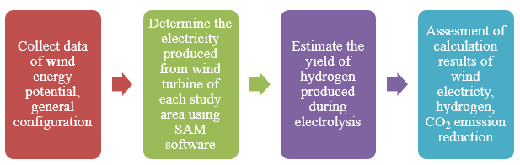
Figure 1. The research method process
SAM software (Janine Freeman et al, 2014) calculates the electricity generated from the wind turbine as follows:
The hourly output is calculated by the equation (1):
$P_{wf,j}=\frac{L}{100\%}x\sum_{n=1}^{N}{P_{j,n}}$ (1)
where: 𝑃_{𝑤𝑓,𝑗} is electrical output of wind farm in hour 𝑗 (kWh/h); 𝐿 is the loss correction factor due to the wake losses (%); 𝑃_{𝑗,𝑛} is electrical output of turbine 𝑛 in hour 𝑗 (kWh/h); 𝑁 is number of turbines in the wind farm.
The annual energy output is determined by the equation (2):
$E_{out}=\sum_{n=1}^{8760}{{(P}_{wf,j }x F_{adj,j})}$ (2)
where: $E_{out}$ is annual electrical energy output (kWh); 𝑃_{𝑤𝑓,𝑗} is electrical output of wind farm in hour 𝑗 (kWh/h); 𝐹_{𝑎𝑑𝑗,𝑗} is the hourly adjustment factor due to various losses; 8760 is number of hours in one year.
Hydrogen production (Rezaei, M., 2019) is estimated by the formulas as below:
$H=\left(\frac{E_{out}}{E_{con}}\right){x eff}_{con}$ (3)
where: H is the amount of hydrogen produced (Nm³); E_{out} is the amount of wind electricity (kWh); eff_{con} is the performance of rectifier efficiency with the value of 95%; E_{con} is the amount the energy consumption of 5 kWh/Nm³ in the electrolyzer.
Equation (4) is used to convert Nm³ to weight (m) in kg (Rezaei, M., 2019):
$m=N {x m^{3} x \left(\frac{1 mol}{0.022414 Nm^{3}}\right)x \left(\frac{0.002016 kg }{ 1 mol}\right)}_{}$ (4)
The average annual CO₂ emission reduction is calculated according to the formula:
R_{tCO2e} = E_{out} x EFgrid (5)
where: R_{tCO2e} is the average annual CO₂ emission reduction (ton); E_{out} is the average annual amount of wind electricity (MWh). EFgrid is the tCO₂ emission coefficient of Vietnam's power grid (0.6766 tCO₂/MWh) (Department of Climate Change, 2024).
3. HYDROGEN PRODUCTION SYSTEM USING WIND POWER
Figure 2 shows the basic block diagram of hydrogen production from a wind power system. In favorable weather conditions, the wind turbine generates electricity to operate the electrolyzer. The electrolyzer is used to separate hydrogen and oxygen molecules from water molecules. The controller is used to control the conversion of alternating current (AC) to direct current (DC) for hydrogen production and supply to local loads. The hydrogen produced will be stored in storage for hydrogen load.
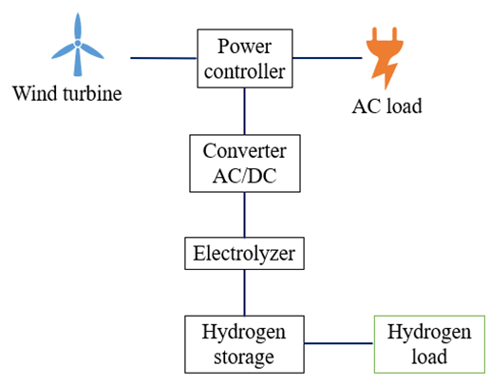
Figure 2. Diagram of hydrogen production from a wind power system
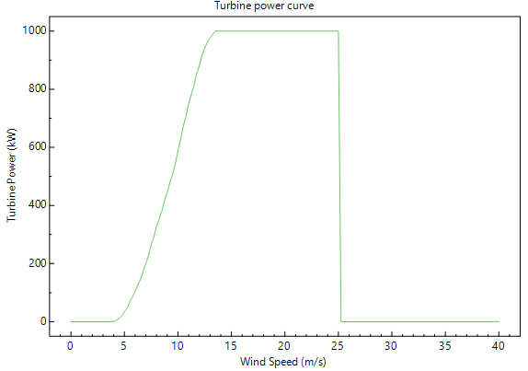
Figure 3. 1 MW wind turbine power curve (National Renewable Energy Laboratory, 2022)
The hydrogen production station uses 1 MW wind turbine from Mitsubishi company (Figure 3) to replace grid electricity using fossil fuels in the electrolysis process. The alkaline electrolyzer system with a total capacity of 1000 kW is used in this hydrogen production station because alkaline is the most popular type for wind electrolysis with the advantages of long life and low cost (Swellam W. Sharshir, 2024). The technical data for simulation of wind turbine and electrolyzer used in the available database in the SAM software version 2022.11.21 (National Renewable Energy Laboratory, 2022).
4. WIND POWER POTENTIAL OF CASE STUDY
Vietnam is located in the tropical monsoon climate zone, with a coastline stretching over 3,000 km, so the potential for wind energy development in Vietnam is extremely large. According to World Bank survey results, Vietnam has the largest wind potential in Southeast Asia, and it is estimated that more than 39% of the total area has an average annual wind speed greater than 6 m/s in height of 65 m, equivalent to 512 GW capacity (World Bank, 2021).
This study will focus on calculating the ability to produce hydrogen using wind power systems in Vietnam based on the wind energy potential in each area, the wind power stations included in the calculation have the same capacity of 1 MW. The study areas in the project include provinces representing eight geographical regions with different climatic conditions as shown in Table 1 and Figure 4. Each province is represented by wind potential data at an altitude of 100 m based on the Global Wind Atlas.
Table 1. Average monthly wind speed of 8 regions at an altitude of 100 m
Unit: m/s
 | Bac Kan | Son La | Ha Noi | Ha Tinh | Phu Yen | Dak Lak | Ho Chi Minh | Tra Vinh
January | 6.73 | 6.89 | 6.26 | 7.21 | 10.21 | 9.77 | 5.45 | 7.70
February | 6.95 | 7.34 | 6.58 | 6.81 | 8.68 | 8.82 | 6.18 | 7.58
March | 7.04 | 7.86 | 6.66 | 6.74 | 7.75 | 7.92 | 6.70 | 7.14
April | 6.86 | 7.56 | 6.50 | 6.30 | 6.78 | 6.28 | 6.31 | 5.84
May | 6.44 | 6.94 | 6.01 | 6.40 | 6.13 | 5.51 | 5.65 | 5.21
June | 5.76 | 7.07 | 5.42 | 8.05 | 6.81 | 7.04 | 6.28 | 6.05
July | 5.87 | 6.64 | 5.43 | 7.96 | 6.87 | 7.36 | 6.49 | 6.30
August | 5.21 | 5.89 | 4.76 | 6.85 | 7.10 | 7.88 | 6.66 | 6.64
Septemper | 6.00 | 6.16 | 5.31 | 6.47 | 5.77 | 5.97 | 5.84 | 5.79
October | 6.69 | 6.55 | 5.86 | 8.24 | 8.15 | 7.17 | 4.78 | 5.05
November | 6.49 | 6.28 | 5.70 | 8.34 | 10.94 | 9.73 | 4.87 | 6.40
December | 6.56 | 6.13 | 5.84 | 7.99 | 11.87 | 10.60 | 4.99 | 7.08
Average | 6.38 | 6.77 | 5.86 | 7.28 | 8.09 | 7.84 | 5.85 | 6.40

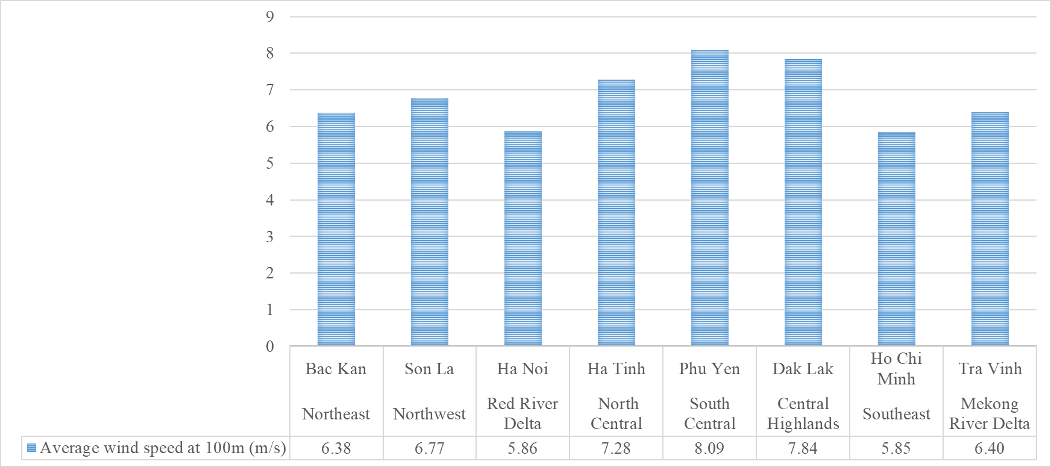
Figure 4. Average annual wind speed of 8 regions at an altitude of 100 m
The average wind speed at an altitude of 100m in Vietnam ranges from 6 m/s to 7 m/s, the average wind speed tends to be higher in the Central regions and down to the Central Highlands and Mekong Delta. The highest average speed is in the South Central region with a value of 8.09 m/s. The area with the lowest average wind speed is in the Red River Delta and the Southeast region with an average speed of approximately 5.9 m/s.
5. RESULTS AND DISCUSSION
The annual average amount of wind electricity and hydrogen are depicted in Figure 5. The study results show that the amount of wind power produced at Phu Yen province (South Central region) and Dak Lak province (Central Highlands region) have the highest values of 2,649,967 kWh/year and 2,497,198 kWh/year, respectively. These are all areas with average to high annual wind speeds and are relatively stable, especially in the Central regions, which are exposed to a long coastline receiving wind resources blowing mostly from offshore to the mainland. Next, Ha Tinh province (North Central region) also has a relatively high output of 2,161,834 kWh/year.
Son La province (Northwest region) with the highest average wind speed among the three localities in the Northern area, so the wind electricity output in the Son La province is the largest value of 1,844,464 kWh/year, followed by Bac Kan province (Northeastern region) with an output of 1,600,872 kWh/year. Hanoi city (Red River Delta region) has the lowest result with an output of 1,281,848 kWh/year because this is a flat and plain terrain area, the variation in wind speed is not high, and climate change between seasons is obvious, so wind speed is not stable.
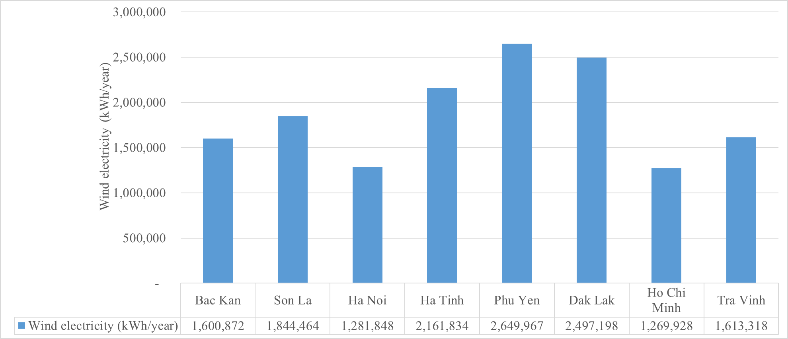
a. Wind electricity
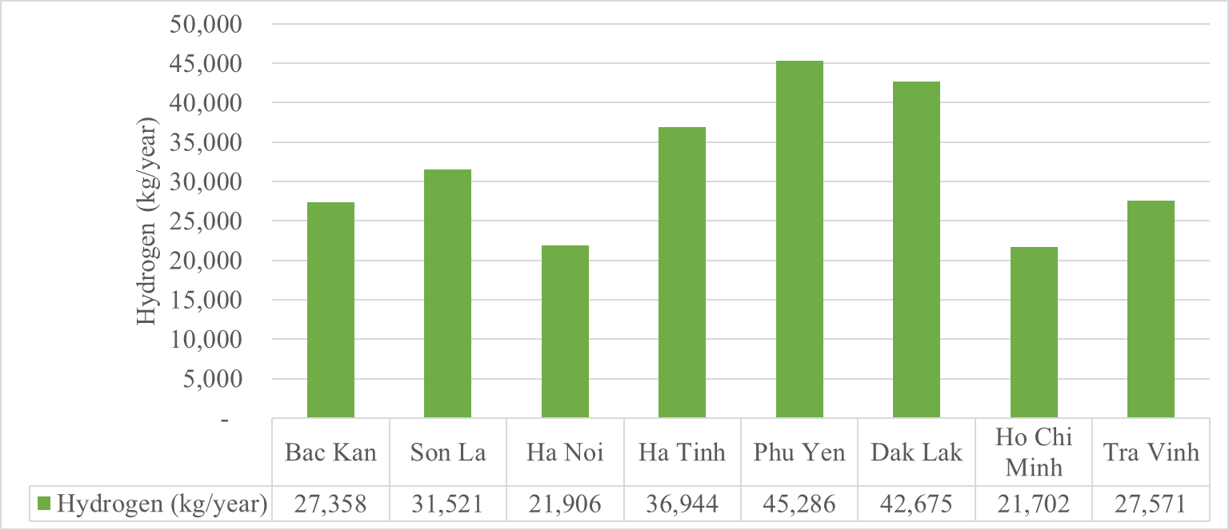
b. Hydrogen
Figure 5. Annual average amount of wind electricity (a) and hydrogen (b)
In the Southern area, Tra Vinh province (Mekong Delta) has high results with a yearly output of 1,613,318 kWh/year. Ho Chi Minh city (Southeastern region) has an electricity output of 1,269,928 kWh/year, this is the lowest value in the Southern area.
The amount of wind electricity generated corresponds to the amount of hydrogen produced. The study results show that Phu Yen province (South Central region) and Dak Lak province (Central Highlands region) have the highest average annual hydrogen production of 45,286.1 kg/year and 42,675.4 kg/year, respectively. Ha Tinh province (North Central region) has hydrogen production of 36,944.3 kg/year. Furthermore, the regions from the North Central region down to the Southeast provinces have great potential for green hydrogen consumption because of key industrial production facilities such as petrochemical refineries, chemicals, and fertilizers. Thus, high hydrogen output will create favorable conditions for the above industries in the regions.
Son La province (Northwest region) and Bac Kan province (Northeast region) also produced relatively good results with hydrogen output of 31,520.6 kg/year and 27,357.8 kg/year, respectively. Hanoi city (Red River Delta) has the lowest hydrogen output of 21,905.9 kg/year. In the Southern area, Tra Vinh province (Mekong Delta) and Ho Chi Minh city (Southeast region) have hydrogen production in a year of 27,570.5 kg/year and 21,702.2 kg/year, respectively.
Figure 6 presents electrolyzer electricity consumption to produce hydrogen from clean electricity of a 1 MW wind turbine. Ho Chi Minh city has the smallest electricity consumption amount of electrolyzer of about 1,206,643 kWh/year, followed by Hanoi city with a value of nearly 1,217,969 kWh/year.
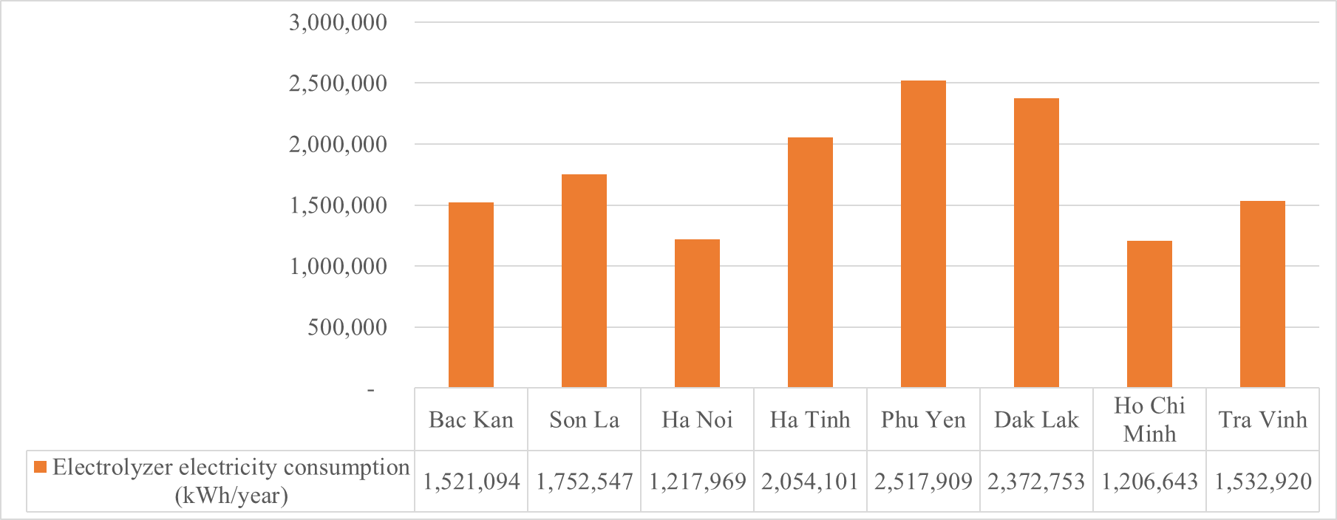
Figure 6. Electrolyzer electricity consumption
Environmental analysis results in Figure 7 and Table 2 present that the use of wind power for hydrogen production will help reduce large amounts of CO₂ emissions into the environment because it has replaced grid electricity using fossil fuels in the electrolysis process. The amount of CO₂ emission reduction is determined by corresponding to the amount of wind power produced during the hydrogen generation process. Phu Yen province has the highest CO₂ emission reduction of 1,792,968 kg/year while Ho Chi Minh city has the smallest value of 859,233 kg/year.

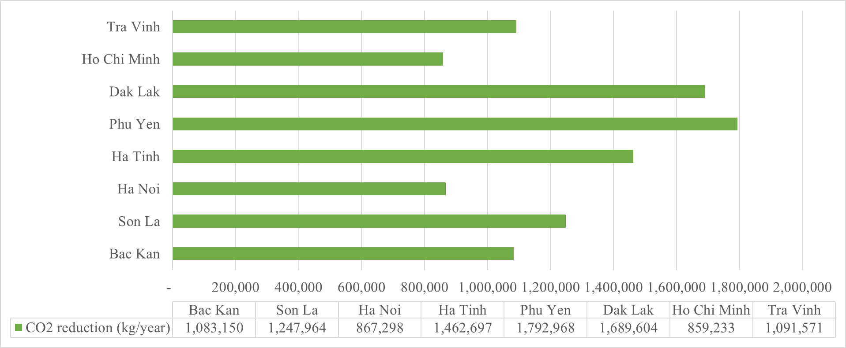
Figure 7. CO₂ emission reduction output in 1 year
Table 2. Output results compared between localities
City/Province | Average wind speed at 100m (m/s) | Electricity (kWh/year) | Hydrogen (kg/year) | CO₂ reduction (kg/year)
Bac Kan | 6.38 | 1,600,872 | 27,357.8 | 1,083,150
Son La | 6.77 | 1,844,464 | 31,520.6 | 1,247,964
Ha Noi | 5.86 | 1,281,848 | 21,905.9 | 867,298
Ha Tinh | 7.28 | 2,161,834 | 36,944.3 | 1,462,697
Phu Yen | 8.09 | 2,649,967 | 45,286.1 | 1,792,968
Dak Lak | 7.84 | 2,497,198 | 42,675.4 | 1,689,604
Ho Chi Minh | 5.85 | 1,269,928 | 21,702.2 | 859,233
Tra Vinh | 6.40 | 1,613,318 | 27,570.5 | 1,091,571
At present, hydrogen production technology from wind power systems is a viable energy conversion trend in the world and a potential technology in Vietnam. The country needs to consider accessing and researching new technologies in production, analyzing and clarifying the hydrogen market in the region, and building and upgrading necessary infrastructure for wind power projects. To overcome those challenges, the Vietnamese government also needs to consider strong, specific, and clear support solutions and policies on roadmaps and orientations to help develop the renewable energy industry, creating favorable conditions for investors, promoting research and application of new technologies, and supporting the promotion of hydrogen use.
In addition, the shortage of highly skilled and specialized workers is also a major obstacle to the development of the hydrogen industry in Vietnam, the use of foreign personnel will increase production costs. Thus, government, management agencies, businesses, educational institutions, and social organizations need to improve training quality, facilities of educational institutions and businesses, increase investment in research and development of hydrogen production technology, etc.
6. CONCLUSIONS
This study presented hydrogen production potential in different regions in Vietnam. The results showed that the annual production of hydrogen depends strongly on the wind power potential. It can be seen that Phu Yen province (South Central region) and Dak Lak province (Central Highlands region) with the highest wind energy potential have the largest hydrogen production of 45,286.1 kg/year and 42,675.4 kg/year, respectively. In contrast, hydrogen production potentials in Hanoi city (Red River Delta region) and Ho Chi Minh city (Southeast region) are the lowest with a value of 21,905.9 kg/year and 21,702.2 kg/year, respectively, because of the lowest wind power output.
Carbon emissions can be reduced by utilizing wind power generated instead of grid power in the electrolysis process. Therefore, Phu Yen province has the highest CO₂ emission reduction of 1,792,968 kg/year while Ho Chi Minh city has the lowest value of 859,233 kg/year.

Acknowledgments:
This work was funded by Vietnam Academy of Science and Technology (VAST), grant number DATT00.01/23-25.
Conflict of Interest
All authors have no conflict of interest to report.

REFERENCES
Anh Tuan Hoang, Ashok Pandey, Eric Lichtfouse, Van Ga Bui, Ibham Veza, Huu Luong Nguyen, Xuan Phuong Nguyen. 2023. Green hydrogen economy: Prospects and policies in Vietnam. International Journal of Hydrogen Energy, Volume 48, Issue 80, pp. 31049-31062.
Ashish Sedai, Rabin Dhakal, Shishir Gautam, Bijaya Kumar Sedhain, Biraj Singh Thapa, Hanna Moussa, Suhas Pol. 2023. Wind energy as a source of green hydrogen production in the USA. Clean Energy, Volume 7, Issue 1, pp 8–22.
Department of Climate change. [Online] http://www.dcc.gov.vn/van-ban-phap-luat/1110/He-so-phat-thai-luoi-dien-Viet-Nam-2022.html [Accessed: 2024-03-25].
Flavia Franco. 2020. Modeling of a Hydrogen Production Plant Supported by Wind and Solar Photovoltaic Sources. Research Dissertation Report of the Master’s Degree.
G. AlZohbi, L. AlShuhail, A. Almoaikel. 2023. An estimation of green hydrogen generation from wind energy: A case study from KSA. Energy Reports, Volume 9, Supplement 11, pp. 262-267.
World Bank, Global Wind Atlas. [Online] https://globalwindatlas.info/en. [Accessed: 2024-03-28].
Javaid, A, Javaid, U, Sajid, M.; Rashid, M, Uddin, E, Ayaz, Y, Waqas, A. 2022. Forecasting Hydrogen Production from Wind Energy in a Suburban Environment Using Machine Learning. Energies, 15, 8901.
Kalppana Chelvam, Marlia M. Hanafiah, Kok Sin Woon, Khalid Al Ali. 2024. A review on the environmental performance of various hydrogen production technologies: An approach towards hydrogen economy. Energy Reports, Volume 11, pp. 369-383.
Li Z, Hou S, Cao X, Sun H, Qin Y, Wang P, Che S. 2021. Modeling and analysis of hydrogen storage wind and gas complementary power generation system. Energy Exploration & Exploitation, 39(4), pp. 1306-1323.
Mostafa Rezaei, Malikeh Salimi, Mozhgan Momeni, Ali Mostafaeipour. 2018. Investigation of the socio-economic feasibility of installing wind turbines to produce hydrogen: Case study. International Journal of Hydrogen Energy, Volume 43, Issue 52, pp. 23135-23147.
National Renewable Energy Laboratory, System Advisor Model Software (version 2022.11.21), 2022.
Nguyen , H. L. 2021. Potential Market and Impact of Clean Hydrogen Development to 2050 in Vietnam. PVJ, 12, pp. 40 - 47.
Nguyen Huu Luong, Nguyen Thi Chau Giang, Huynh Minh Thuan. 2020. Hydrogen production from renewable resources for use in refineries and petrochemical plants in Vietnam. PVJ, vol. 11, pp. 37 - 55.
Swellam W. Sharshir, Abanob Joseph, Mamoun M. Elsayad, Ahmad A. Tareemi, A.W. Kandeal, Mohamed R. Elkadeem. 2024. A review of recent advances in alkaline electrolyzer for green hydrogen production: Performance improvement and applications. International Journal of Hydrogen Energy, Volume 49(C), pp.458-488,
Opakhai, S., Kuterbekov, K., Zhumadilova, Z. 2024. Hydrogen energy in Kazakhstan: prospects for development and potential. Polityka Energetyczna – Energy Policy Journal, 27(2), pp.141-194.
Prime Minister. 2023. National electricity development plan for the period 2021 - 2030 vision to 2050.
Prime Minister. 2024. Decision 165/QD-TTg approving Vietnam's hydrogen energy development strategy to 2030, vision to 2050.
Qusay Hassan, Ahmed K. Nassar, Ali Khudhair Al-Jiboory, Patrik Viktor, Ahmad A. Telba, Emad Mahrous Awwad, Ayesha Amjad, Hassan Falah Fakhruldeen, Sameer Algburi, Saoud Chayid Mashkoor, Marek Jaszczur, Aws Zuhair Sameen, Maha Barakat. 2024. Mapping Europe renewable energy landscape: Insights into solar, wind, hydro, and green hydrogen production. Technology in Society, Volume 77, 102535.
Rezaei, M., Mostafaeipour, A., Qolipour, M., Momeni. M. 2019. Energy supply for water electrolysis systems using wind and solar energy to produce hydrogen: a case study of Iran. Front. Energy 13, pp. 539–550.
Thi Pham Phan, Tuan Loi Nguyen, Phan Khanh Thinh Nguyen. 2023. Evaluation and enhancement of hydrogen production from Vietnamese macroalgae in the single-stage of dark fermentation and microbial electrolysis cell. Biomass and Bioenergy, Volume 175, 106885.
Vu Minh Phap, Le Quang Sang, Nguyen Quang Ninh, Doan Van Binh, Bui Bao Hung, Cu Thi Thanh Huyen, Nguyen Thanh Tung. 2022. Feasibility analysis of hydrogen production potential from rooftop solar power plant for industrial zones in Vietnam, Energy Reports, Volume 8, pp. 14089-14101.
World Bank (WB). 2001. Wind energy resource atlas of Southeast Asia.
Xue Q, Wang Z, Zhang Y. 2021. Environmental Benefit and Investment Value of Hydrogen-Based Wind-Energy Storage System. Front. Energy Res. 9:629136.
X. Wu, H. Li, X. Wang, W. Zhao. 2020. Cooperative Operation for Wind Turbines and Hydrogen Fueling Stations With On-Site Hydrogen Production. IEEE Transactions on Sustainable Energy, vol. 11, no. 4, pp. 2775-2789.
Yi Zheng, Shi You, Chunjun Huang, Xin Jin. 2023. Model-based economic analysis of off-grid wind/hydrogen systems. Renewable and Sustainable Energy Reviews, Volume 187, 113763.

